MAKERERE UNIVERSITY

COLLEGE OF COMPUTING AND INFORMATION SCIENCES

SCHOOL OF COMPUTING AND IT

END OF SEMESTER I EXAMINATION 2014/2015

PROGRAMME: CS, SE

YEAR OF STUDY: II

COURSE NAME: Discrete Mathematics MKG GUIDE

COURSE CODE: MTH 3105

EXAMINATION INSTRUCTIONS

- ATTEMPT ALL QUESTIONS IN SECTION A (40 MARKS)

- ATTEMPT ANY THREE (03) QUESTIONS IN SECTION B (60 MARKS)

- DO NOT OPEN THIS EXAM UNTIL YOU ARE TOLD TO DO SO

- ATTEMPT EACH QUESTION IN SECTION B ON A NEW PAGE

- ALL ROUGH WORK SHOULD BE IN YOUR ANSWER BOOKLET

SECTION A (40 Marks)
Question A
Describe the following sets in both formal and informal ways. (1 Mark @)
Formal Set Notation Description | Informal English Description
- {n | n, m ⁺ and n = 2m+1} or  {1, 3, …} | The set of all positive odd integers
(ii) {n | n, m and n = 2m} or  {-4, -2, 2, 4, …} | The set of all even integers
(iii) {n | n, ⁻ and n = 2m and m } or {…, -4, -2} | The set of all negative even integers  (using the convention that 0 is not a natural number)
- {n | n, m ⁺ and n = 6m} or  {0, 6, 12, …} | The set of all positive multiples of 6
- {2, 20, 200} | The set containing the numbers 2, 20, and 200
- {n | n and n > 42} | The set of integers greater than 42
(vii) {n | n and n < 42 and n > 0}  = {n | n and n < 42} | The set of natural numbers less than 42
- {hello} | The set containing the string ‘hello’
- {bba, bab} | The set contining the strings ‘bba’ and ‘bab’
- φ = {} | The empty string character

Question B
Using the product rule notation, prove that if |A| = n and |B| = m, then |AxB| = mn (6 Marks)
By counter example: (1) if A= {a1,a2,a3} and B={b1,b2} (1)
we see that AxB = {(a1,b1), (a1,b2), (a2,b1), (a2,b2), (a3,b1), (a3,b2)} (2)
it is clear that |A|=3, |B|=2 and |AxB|=6. (2)Which proves the given inequality/equality

Question C
Represent the following statements using predicate logic (2 Marks @)
- There is someone in this class who doesn’t have a good attitude
- Some drivers do not obey speed limits
- Every bird can fly.
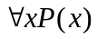, x: “a bird can fly”
- No one can keep a secret.

Question D
Determine whether the function f, in each of the following cases is surjective or not. Give a reason for your answer.
- f from {a, b, c, d} to {1,2,3} defined by f(a) = 3, f(b) = 2, f(c) = 1 and f(d) = 3 (4 Marks)
With reference to the figure below
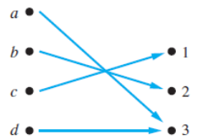 (2)
Because all three elements of the codomain are images of elements in the domain, we see that f is surjective (2)

- f(x) = x² from the set of integers to the set of integers (2 Marks)
The function f is not surjective (1) because there is no integer x with x² =−1, for instance (1)

Question E
Briefly expound on the different types of graphs (please use diagrams to do so) (10 Marks)

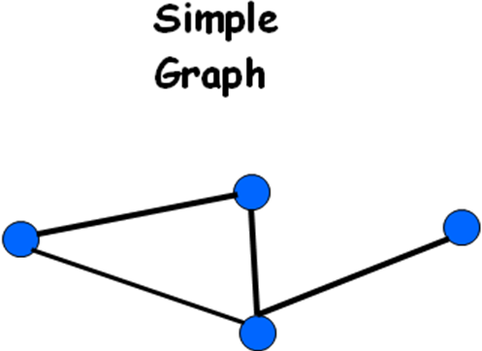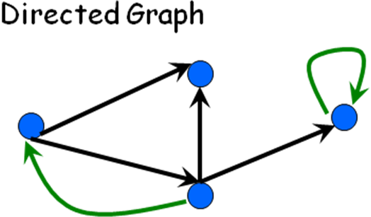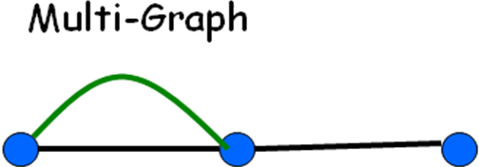
(3) (3) (3)
A student should write some accompanying explanation with each diagram; else they awarded half the marks
A student who gets all of them right, is awarded 1 bonus mark.

SECTION B (60 Marks)

Question 1
a) There are 200 students in a school. Out of these, 100 students play baseball, 50 students play hockey, and 60 students play basketball. 30 students play both baseball and hockey, 35 students play both hockey and basketball, and 45 students play both basketball and baseball. Compute the following:
We can interpret the above information in the following way with the aid of a Venn diagram
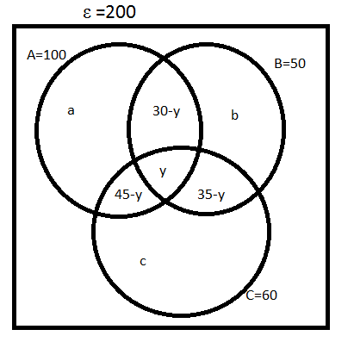
Correct Venn diagram carries 6 Marks
(i) The maximum number of students who play at least one game (2 Marks) = 200 [1]
(ii) The maximum number of students who play all the 3 games (3 Marks) = y [1]
(iii) The minimum number of students playing at least in one game (3 Marks) = a+b+c [1]
(iv) The minimum number of students playing all the 3 games (2 Marks) = y [1]
b) Let U = {xZ | 1 <= x <= 50
A = {xU | x is divisible by 2}, B = {xU | x is divisible by 5}
A B = {xU | x is divisible by 10}
A B = {xU | x is divisible by 2 or is divisible by 5 (or both)}
A – B = {xU | x is divisible by 2 but is not divisible by 5}
Compute:
(i) |A|: A ={2, 4, 6, 8, …, 50} (1), so |A|= 25 (1)
(ii) |B|: B = {5, 10, …, 50} (1), |B| = 10 (1)
(iii) |A B|: A B = {10, 20, 30, 40, 50} (1), | A B| = 5 (1)
(iv) |AB|= |A| + |B| - | A B| (1) = 25+10-5 = 30 (1) OR AB = {2,4,5,6,,8,10,12,14,15,16,18,20,22,24,25,26,28,30,32,34,35,36,38,40,42,44,45,46,48,50} (1) making | AB| = 30 (1)
(v) |A – B|= |A|- | A B |(1)= 25-5 = 20 (1) OR list members of set A-B and then count

Question 2
a) How many passwords satisfy the following requirements? (12 Marks)
- between 6 & 8 characters long
- starts with a letter
- case sensitive
- other characters: digits or letters
Let L be set of letters and D be set of digits (1)
L = {a, …, z, A, …,Z} case sensitive means that lower case letters are different from upper case letters(2)
D = {0, 1, …, 9}(1)
In counting, we are interested in quantity, hence |L| = 52 and |D| = 10 (1)
passwords with 6 characters long are counted from a set as follows
P _{6 Characters} = L x LUD x LUD x LUD x LUD x LUD by Cartesian product rule(1)
So, |P _{6 Characters}| = |L x LUD x LUD x LUD x LUD x LUD|= |L|* |LUD|⁵ by product rule. (1)
So total passwords are |P _{6 Characters}|+ |P _{7 Characters}|+|P _{8 Characters}| (1)
= |L|* |LUD|⁵ + |L|* |LUD|⁶ + |L|* |LUD|⁷ (1)
Because L and D are mutually disjoint sets, |LUD| = |L| + |D|= 52 +10 = 62 (2)
Therefore total passwords = 52*62⁵ + 52*62⁶ + 52*62⁷ (1)
b) In how many ways can we select three students from a group of five students to stand in line for a picture? (4 Marks)
The order in which we select the students matters (0.5).
There are 5 ways to select the 1st student to stand at the start of the line (0.5).
There are 4 ways to select the 2nd student in the line (0.5).
There are 3 ways to select the 3rd student in the line. (0.5).
By the product rule (1), there are 5 * 4* 3 = 60 ways to select three students from a group of five students to stand in line for a picture. (1)
c) In how many ways can we arrange all five of these students in a line for a picture? (4 Marks)
To arrange all five students in a line for a picture, we select the first student in five ways, the second in four ways, the third in three ways, the fourth in two ways, and the fifth in one way (2.5). Consequently, there are 5 * 4 * 3 * 2 * 1 = 120 (1.5) ways to arrange all five students in a line for a picture.

Question 3
a) Let p and q be the propositions
p: I bought a lottery ticket this week.
q: I won the million dollar jackpot.
Express each of these propositions as an English sentence. (8 Marks)
i) ￢p: I did not buy a lottery ticket this week
ii) p ∨ q: Either I bought a lottery ticket this week or won the million dollar jackpot
iii) p → q: This week, if I bought a lottery ticket then I had won the million dollar jackpot.
iv) p ∧ q: This week, I bought a lottery ticket and won the million dollar jackpot
v) p ↔ q: If and only if I had bought a ticket this week, I would have won the million dollar jackpot
vi) ￢p →￢q: If I did not buy a ticket this week, I would not have won the million dollar jackpot
vii) ￢p ∧￢q: I didn’t buy a lottery ticket this week and did not win the million dollar jackpot.
viii) ￢p ∨ (p ∧ q): I won the million dollar jackpot this week having bought or not bought a lottery this ticket.
b) Determine whether each of these conditional statements is true or false. (2 Marks)
i) If 1 + 1 = 2, then 2 + 2 = 5. False 0.5
ii) If 1 + 1 = 3, then 2 + 2 = 4. True 0.5
iii) If 1 + 1 = 3, then 2 + 2 = 5. True 0.5
iv) If monkeys can fly, then 1 + 1 = 3. True 0.5
c) Translate the following English statements into logical expressions (5 Marks)
i) You can access the Internet from campus only if you are a computer science major or you are not a freshman
let r: accessing the internet, p: one is a computer science major and q: one is a fresh man (1.5)
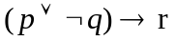 (1)
ii) You cannot ride the roller coaster if you are under 4 feet tall unless you are older than 16 years old:
Statement is equivalent to saying that if you are under 4 feet tall, you can only ride a roller coaster if you are over 16 years of age.
Let r: riding a roller coaster, p: one is under four feet tall and q: one is over 16 years (1.5)
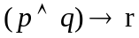 (1)
d) Determine whether these system specifications are consistent: (5 Marks)
“The diagnostic message is stored in the buffer or it is retransmitted.”
“The diagnostic message is not stored in the buffer.”
“If the diagnostic message is stored in the buffer, then it is retransmitted.”

System specifications should be consistent, that is, they should not contain conflicting requirements that could be used to derive a contradiction (1)
Let p denote “The diagnostic message is stored in the buffer” and let q denote “The diagnostic message is retransmitted.” (1)
The specifications can then be written as
p ∨ q, ￢p, and p → q. (1)
An assignment of truth values that makes all three specifications true must have p false to make ￢p true. Because we want p ∨ q to be true but p must be false, q must be true. Because p → q is true when p is false and q is true, we conclude that these specifications are consistent, because they are all true when p is false and q is true. (2) OR
we could come to the same conclusion by use of a truth table to examine the four possible assignments of truth values to p and q.
Question 4
a) Using an appropriate technique, prove the theorem 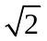 is irrational. (8 Marks)
Use Proof by contradiction method (2)
Suppose is rational. (2)
Choose m, n integers without common prime factors (always possible) such that 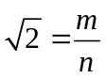 (1)
Show that m and n are both even, thus having a common factor 2, which is a contradiction! (3)
b) Show that if n is a positive integer, then 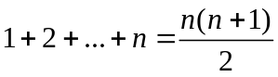 (12 Marks)
Use proof by induction (2)
Show that LHS =RHS where n=0, 1 (3)
As a hypothetical step, show that RHS = LHS when n is the value in consideration (3)
As an induction step, show LHS =RHS when n is a step further, i.e. n+1 (4)

Question 5
a) Briefly illustrate and discuss the Seven Bridges of Königsberg problem is relation to graph theory and the Eularian solution (7 Marks)
The “Seven Bridges of Königsberg problem” provides a discussion about the possible to walk with a route that crosses each bridge exactly once. (1)
From the literature, the map of the city of Königsberg can be illustrated as below, with less details
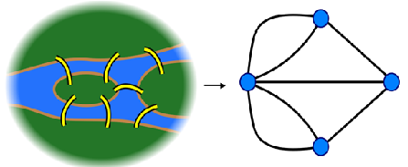(2)

Labeling the graph results into the illustration below
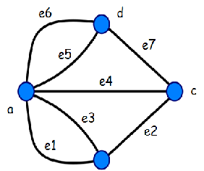
e=edge, a, b, c, d are vertices (1)
Reducing the problem to the question “Is it possible to find a walk that visits each edge exactly once?” (1)
If it is possible then, for every “intermediate” point v, there must be the same number of incoming and outgoing edges, and so v must have an even number of edges. (1)
It is not possible in this case. According to Euler, it makes the problem unsolvable. (1)
b) Visualize each of the following graphs, and state whether or not it is simple. (3 Marks)
(i) G1 = (V1, E1), where V1 = {a, b, c, d, e} and E1 = {ab, bc, ac, ad, de}.
Mark given only when the diagram is correct.
a
c
b
d
e

simple

(ii) G2 = (V2, E2), where V2 = {P, Q, R, S, T} and E2 = {PQ, PR, PS, PT, TR, PR}.

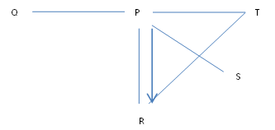Not simple

(iii) G3 = (V3, E3), where V3 = {v1, v2, v3, v4, v5} and E3 = {v1v1, v1v2, v2v3, v3v4, v5v4, v4v5}.

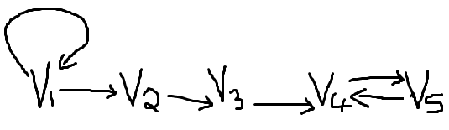 Not simple
c) Determine whether or not each of the following pairs of graphs are isomorphic or not: (10 Marks)
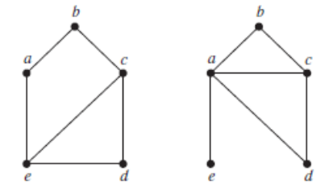
Figure 1
Correct details below (3 Marks)
 | Graph on the left, GL | Graph on the right, GR
No. of Vertices | a,b,c,d,e =5 | a,b,c,d,e =5
No. of Edges | ab,ae,bc,cd,ce,de = 6 | ab,ac,ad,ae,bc,cd = 6
Degree sequence | (2,2,3,2,3) | (4,2,3,2,1)
GR and GL are not isomorphic because of the differences in degree sequence and lack of edge preserving nature (2)
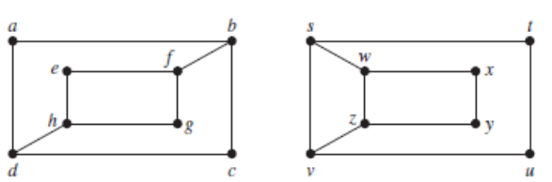
Figure 2

Correct details below (3 Marks)

 | Graph on the left, GL | Graph on the right, GR
No. of Vertices | a,b,c,d,e,f,g,h=8 | s,t,u,v,w,x,y,z =8
No. of Edges | ab,ad,bc,bf,cd,dh,ef,eh,fg,gh = 10 | st,sv,sw,tu,uv,vz,wx,wz,xy,yz = 10
Degree sequence | (2,3,2,3,2,3,2,3) | (3,2,2,3,3,2,2,3)
GR and GL are not isomorphic because of the differences in degree sequence and lack of edge preserving nature (2)

==END==

